**Sharp MZ 80K**

The MZ-80K was, alongside the Apple II, the Commodore PET and the Tandy TRS 80抯 one of the best known computer in the early 80's. Its name stands for "M" from MICRO and Z-80 from the computer it uses.

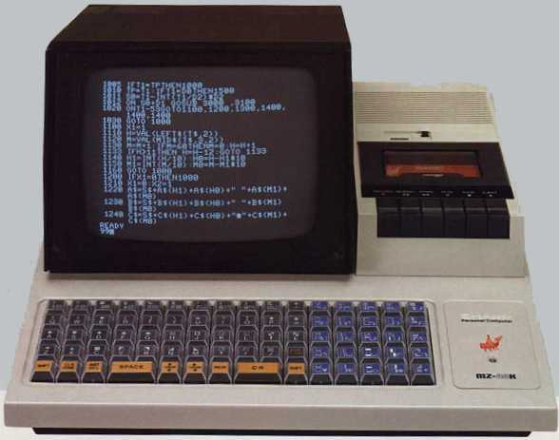

It has no language in ROM, and BASIC has to be loaded from tape. Sharp called this "clean design", as you could choose what you wanted to put in your computer, the MZ-80K being delivered clean... Though a 5.25" floppy disk unit was later available, most people never used anything else than the built-in tape recorder (1200 bps).

There is no colour, no high resolution and characters sets can't be redefined. But the pre-defined characters set was very complete offering a lot of different graphical symbols, and people (mainly japanese) created great games, overcoming the main flaw of the MZ-80 serie... A graphic card was later designed for this computer, allowing to redefine the characters set resulting in a virtual "high resolution" of 320 x 192 pixels.

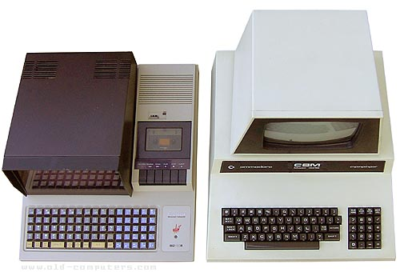

The MZ-80K is equiped with a real clock and a built-in speaker.

First MZ-80K were sold in Japan as assembly kits (1978). In 1980, Sharp released the MZ-80K2 which is basicaly a MZ-80K with 32 KB RAM, a non-reflective keyboard and and a volume control at the rear of the system. One year later, a cost reduced version, the MZ-80K2e, was marketed as an anniversay model when MZ serie sales reached one hundred thousand machines.

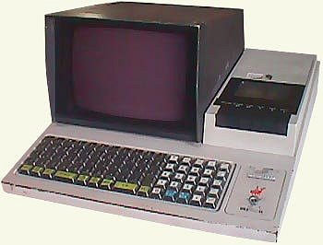

|  |  |
| --- | --- |
|  |  |

|  |  |
| --- | --- |
| **NAME** | MZ 80K |
| **MANUFACTURER** | Sharp |
| **TYPE** | Home Computer |
| **ORIGIN** | Japan |
| **YEAR** | 1979 |
| **BUILT IN LANGUAGE** | Sharp Basic available on tape |
| **KEYBOARD** | Strange transparent square keys. 78 keys. Numeric keypad |
| **CPU** | Sharp LH-0080 (Zilog Z80 A compatible) |
| **SPEED** | 2 MHz |
| **RAM** | 20 KB (up to 48 KB) MZ-80K2 & K2e: 32 KB |
| **ROM** | 4 KB |
| **TEXT MODES** | 40 x 25 (8 x 8 character matrix) |
| **GRAPHIC MODES** | 80 x 50 |
| **COLORS** | built-in 10'' black & white monochrome monitor |
| **SOUND** | one channel |
| **SIZE / WEIGHT** | 410 (W) x 470 (D) x 270 (H) mm / 13 kg |
| **I/O PORTS** | Expansion bus |
| **BUILT IN MEDIA** | Tape recorder |
| **POWER SUPPLY** | Built-in PSU |
| **PERIPHERALS** | RAM expansions, printer, Floppy drives unit, color display |
| **PRICE** | MZ-80K: 198,000 yen (1978, japan) MZ-80K2: 198,000 yen (1980, japan) MZ-80K2e: 148,000 yen (1981, japan) |

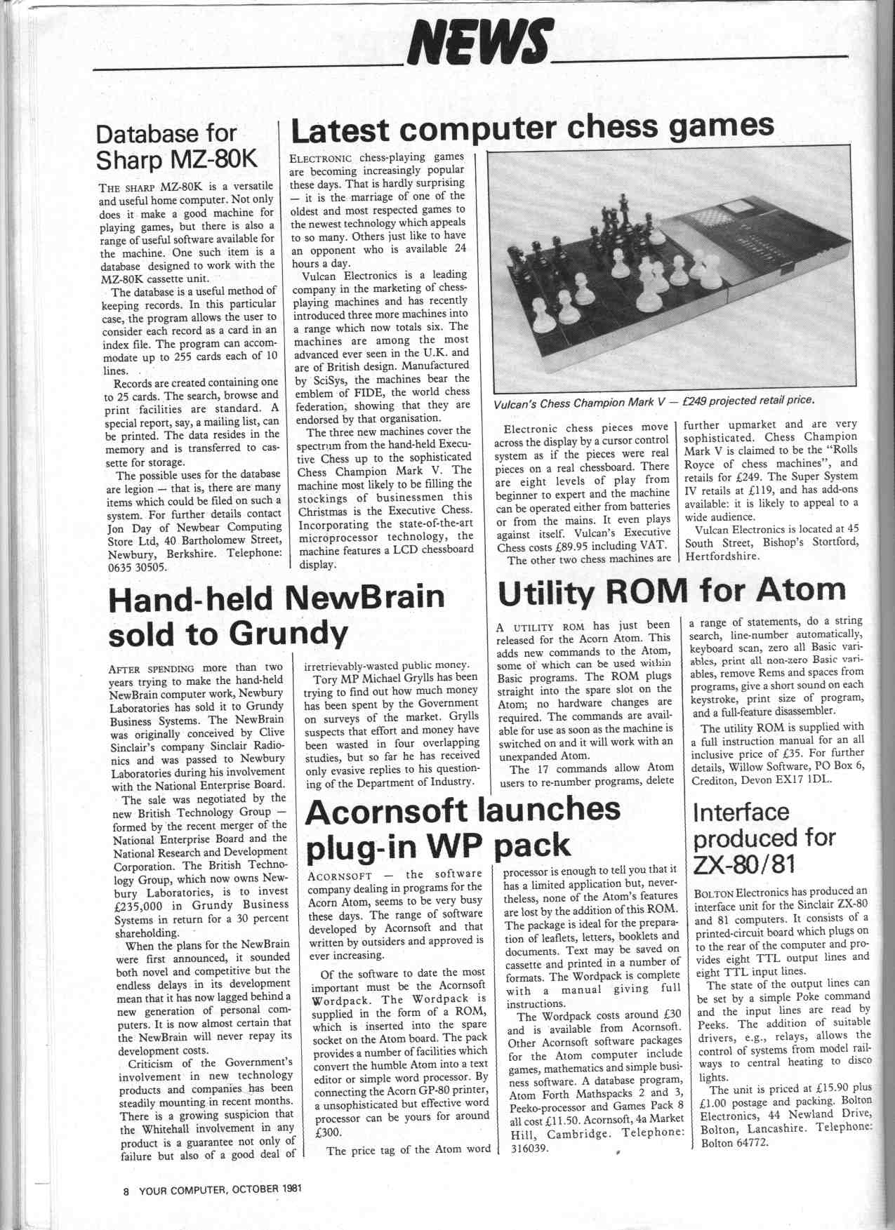

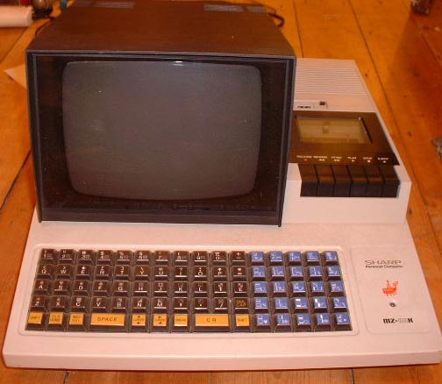

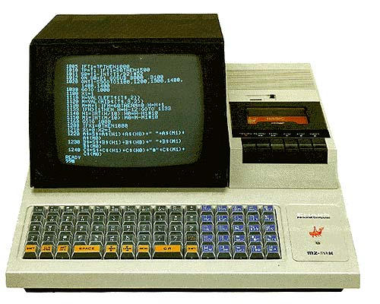

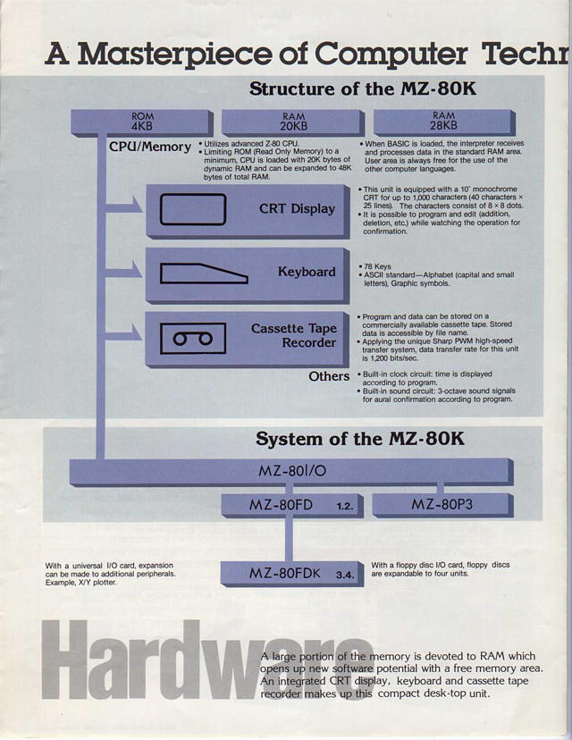

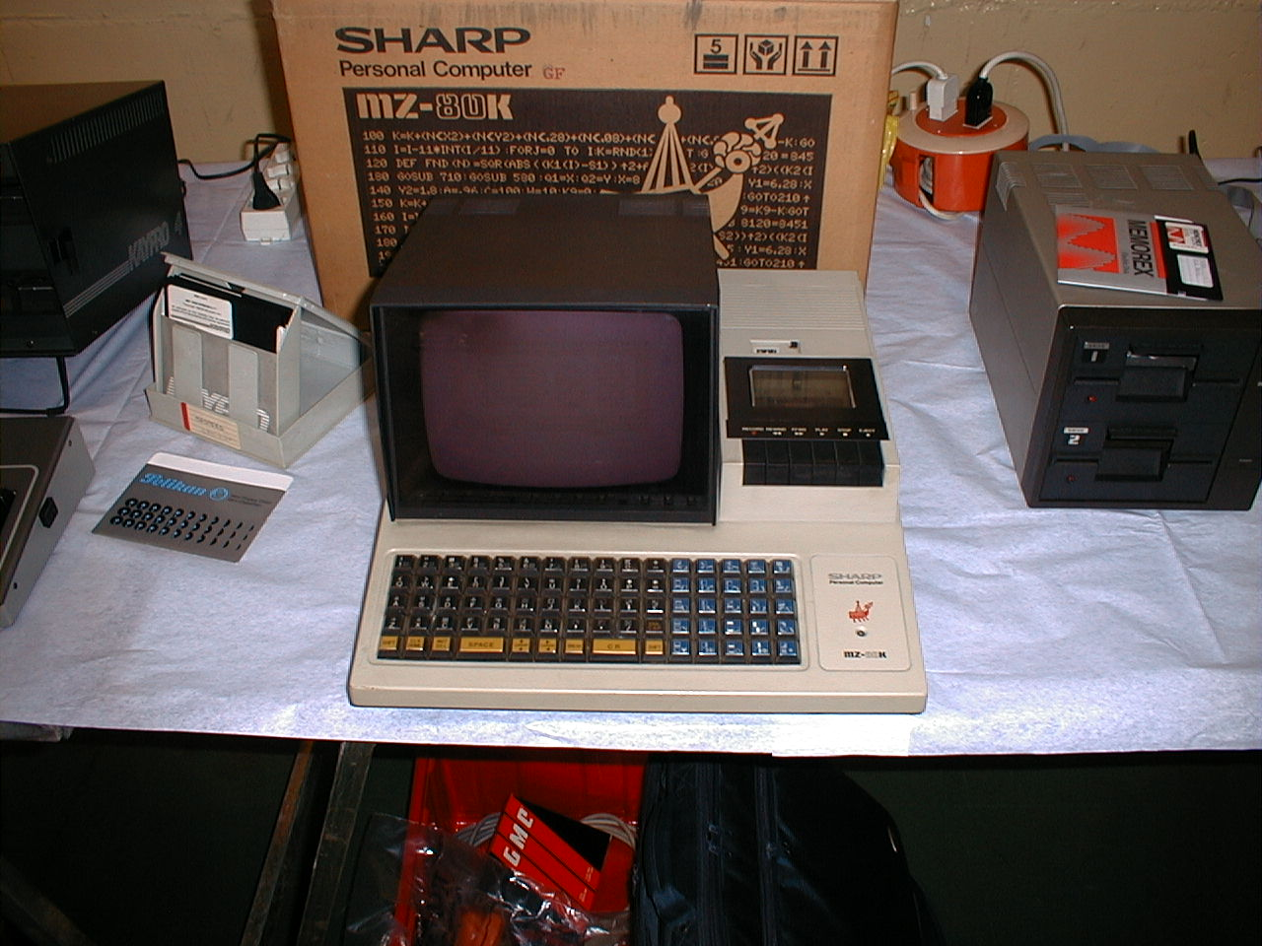

参考文献[回目录](http://www.techcn.com.cn/index.php?doc-view-141138.html" \l "section)

http://www.old-computers.com/museum/computer.asp?st=1&c=174  
http://en.wikipedia.org/wiki/Sharp_MZ